STOCK TRADING PLATFORM
Submitted By
Name: Mitushi Jain
Internship: CodeAlpha Java Programming Internship

1. Objective
The objective of this project is to develop a simple Stock Trading Platform using Java. The application allows users to view stock prices, buy stocks, and track their portfolio. This project demonstrates the use of Java programming concepts such as loops, conditional statements, user input handling, and basic portfolio management.

2. Tools Used
- Java
- JDK (Java Development Kit)
- Visual Studio Code
- Command Prompt / Terminal

3. Project Description
The Stock Trading Platform is a console-based Java application that simulates a basic stock market environment. Users can view available stocks and their prices, purchase shares, and monitor their investments. The system keeps track of the user's balance and portfolio value.

4. Features
- Display available stocks and prices.
- Buy stocks based on available balance.
- Maintain a virtual portfolio.
- Track purchased shares.
- Calculate portfolio value.
- User-friendly menu-driven interface.

5. Working Procedure
- The program starts with an initial balance of ₹10,000.
- Users can view available stocks and their market prices.
- Users select a stock and enter the quantity they wish to purchase.
- The system checks whether sufficient balance is available.
- If the transaction is successful, the stock is added to the portfolio.
- Users can view their portfolio and remaining balance at any time.
- The program continues until the user chooses to exit.

6. Output Screenshots
Figure1: Main Menu
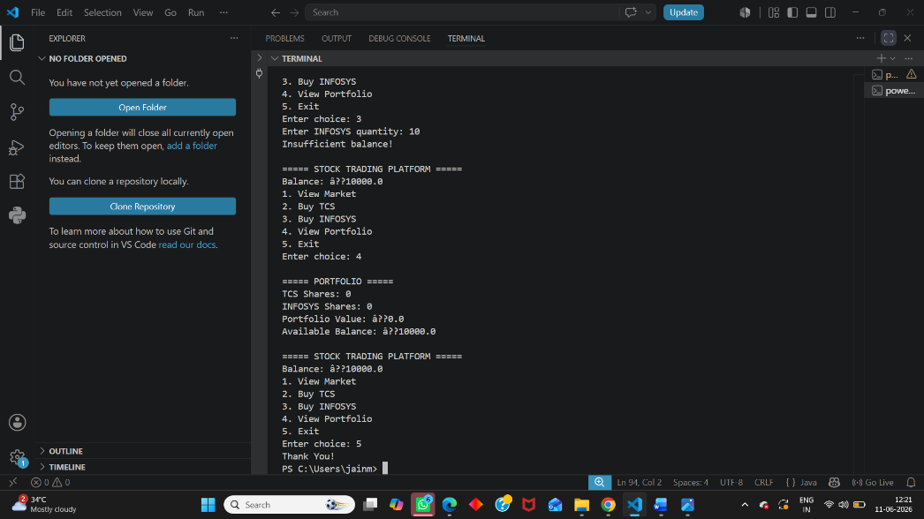
Figure 2: Stock Purchase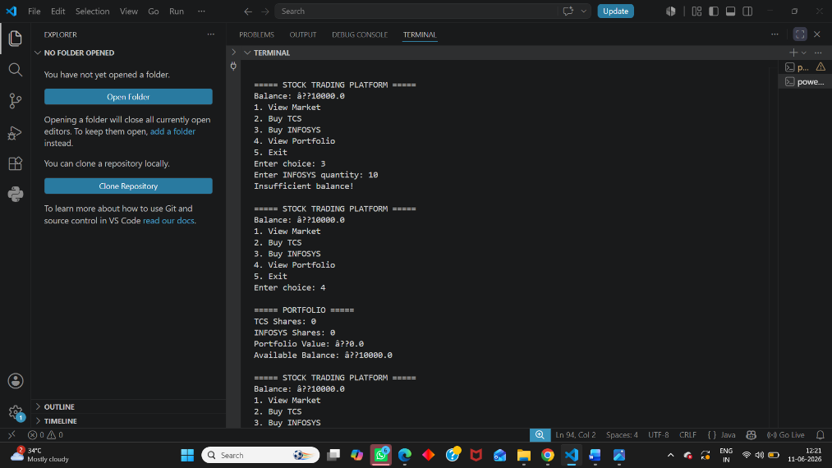
Figure 3: Portfolio Details
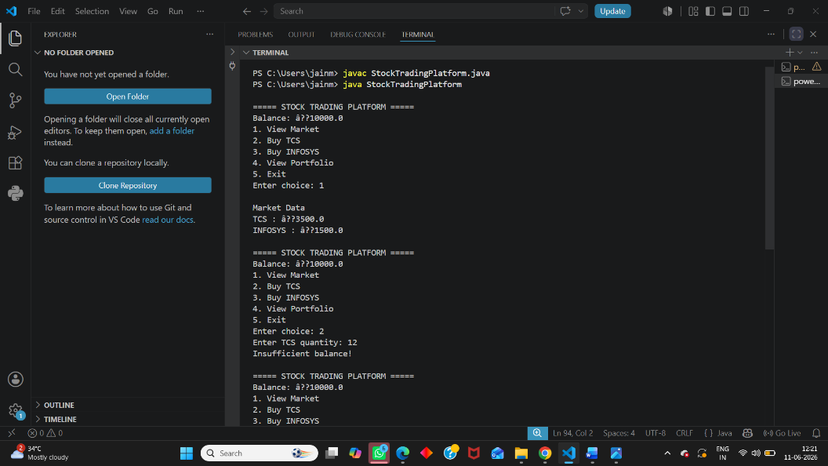
7. Advantages
- Easy to understand and use.
- Demonstrates Java programming concepts.
- Simulates basic stock trading operations.
- Helps understand portfolio management.

8. Limitations
- Uses fixed stock prices.
- No real-time stock market integration.
- No database storage.
- Limited number of stocks.

9. Future Enhancements
- Real-time stock market data integration.
- Database connectivity.
- User authentication system.
- Graphical User Interface (GUI).
- Profit and loss analysis.
- Transaction history tracking.

10. Conclusion
The Stock Trading Platform successfully simulates basic stock trading operations using Java. The project allows users to view stock prices, purchase shares, and monitor their portfolio. It provides practical experience with Java programming, menu-driven applications, and simple financial calculations.

11. References
- Oracle Java Documentation
- Java Programming Tutorials
- VS Code Documentation
- CodeAlpha Internship Guidelines

